# Homework 3 - Policy Based Management

* Screenshots should show the full contents of the conditions and policy you have created, not just the names.
* **Task 1.** Show in a screenshot the condition(s) you have created.

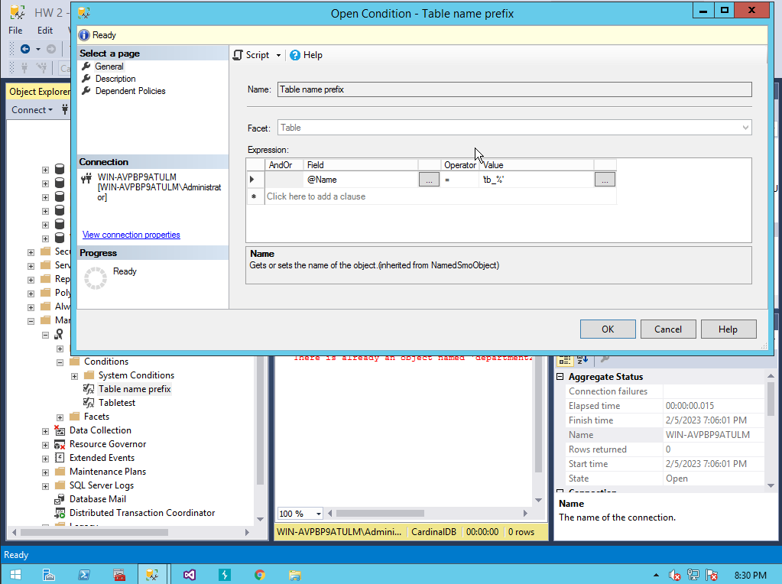

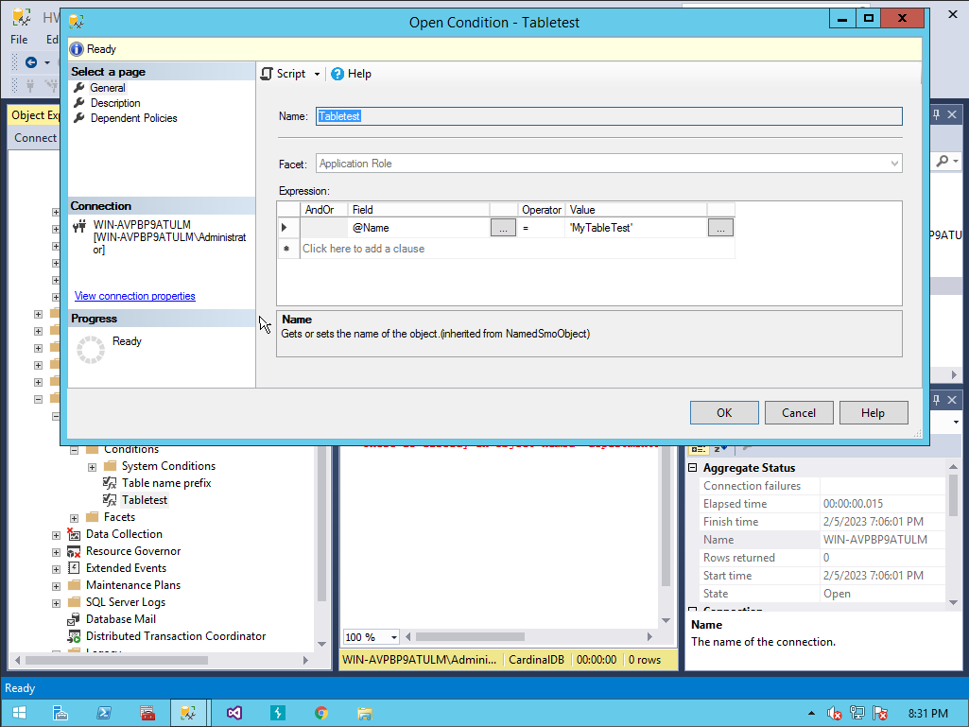

* **Task 2.** Show in a screenshot the policy you have created.

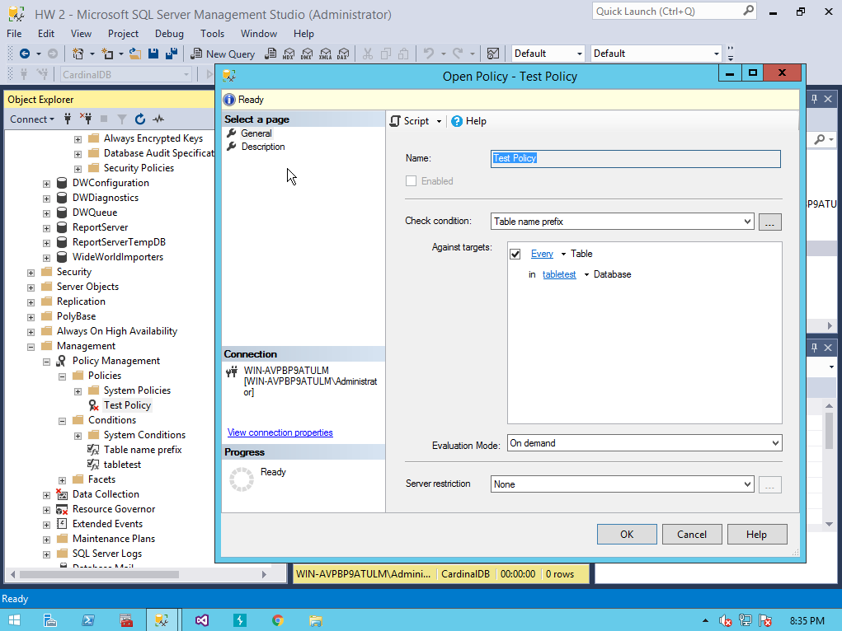

* **Task 3.** Show in a screenshot the test results using the four tables that are provided above.

